Use Certificate Enrollment Wizard to create a custom Certificate Signing Request (CSR)

1. Log on to the server as a member of the local Administrators group.
2. Click **Start**.
3. In the **Search programs and files** box, type **mmc.exe**, and press ENTER.
4. On the **File** menu, click **Add/Remove Snap-in**.
5. In the list of available snap-ins, click **Certificates**, and then click **Add**.
6. Click **Computer account**, and click **Next**.
7. Click **Local computer**, and click **Finish**.
8. Click **OK**.
9. In the console tree, double-click **Certificates (Local Computer)**, and then double-click **Personal**.
10. Right-click **Personal**, point to **All Tasks**, point to **Advanced Operations** and then click **Create Custom Request** to start the Certificate Enrollment wizard.

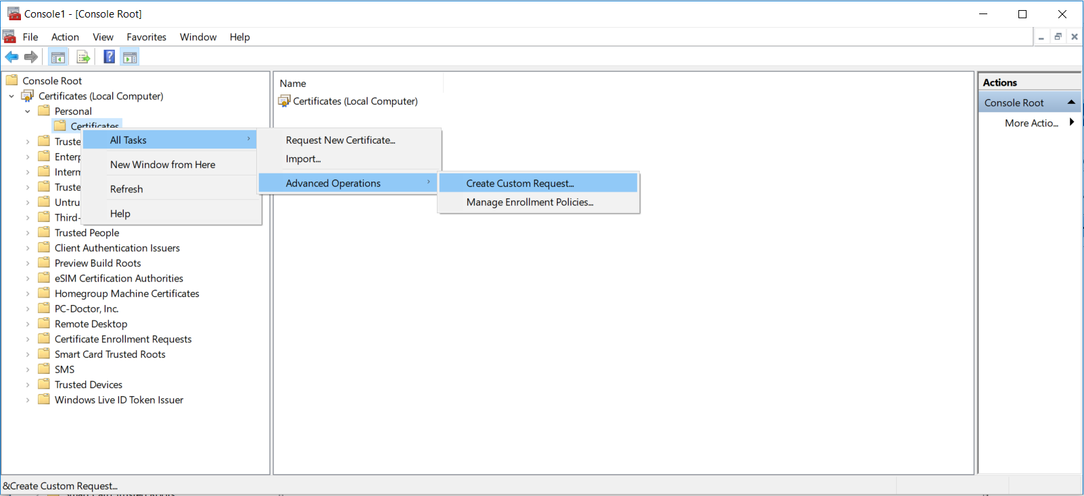

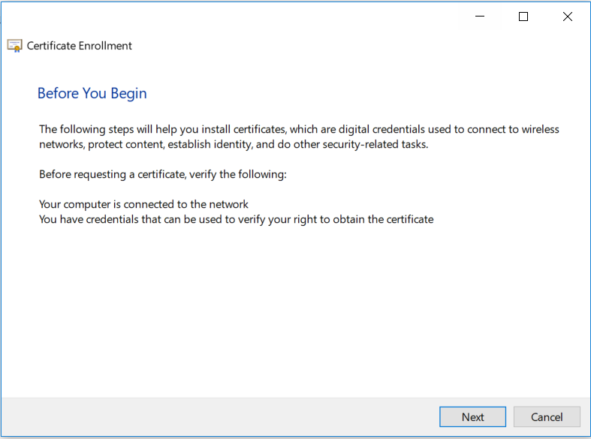

1. Click **Next**.

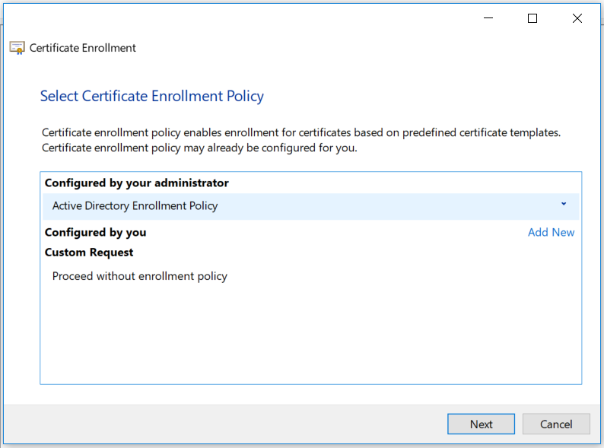

1. Click **Next**.

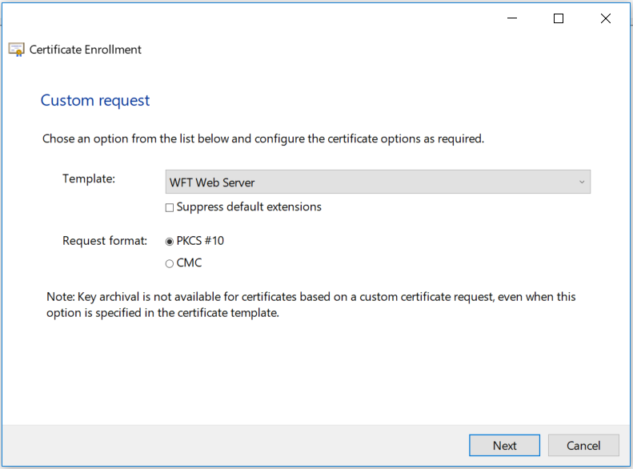

1. Select the WFT Web Server Template and click **Next**.

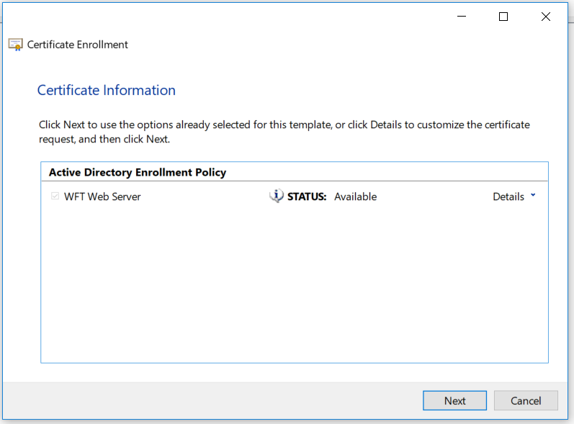

1. Click arrow to the right of **Details** in the **Active Directory Enrollment Policy** area to review more options.

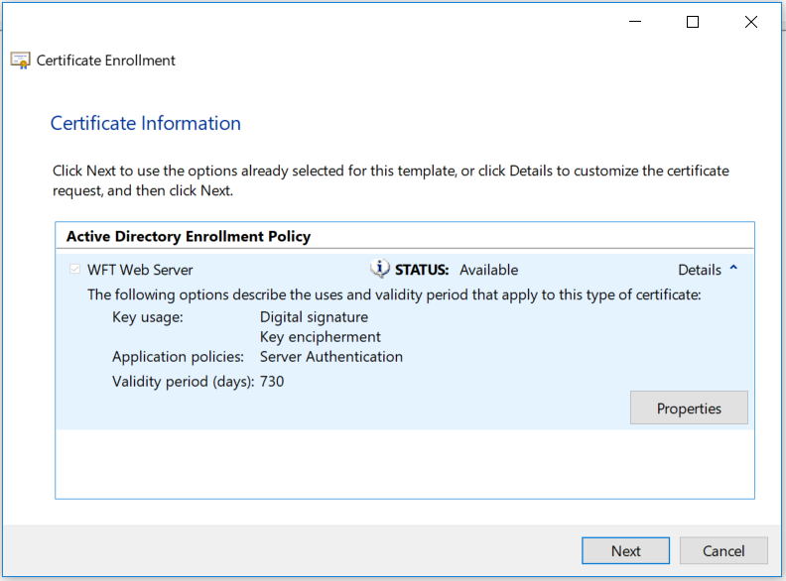

1. Click **Properties.** A dialog box very similar to the IIS certificate dialog box will appear.

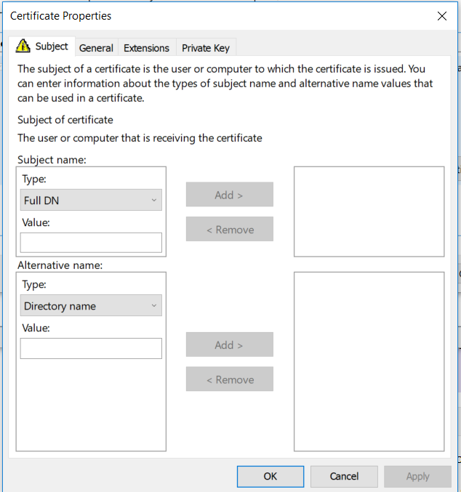

1. In the **Subject name** area under Type, click Common Name. In the **Subject name** area under **Value**, enter the fully qualified domain name of the server, and then click **Add**.

**Note**: Because SSL/TLS does not require a Subject name when a SAN extension is included, the Subject name can be empty. If you are using another protocol, verify the certificate requirements. To use an empty Subject name, skip step 15.

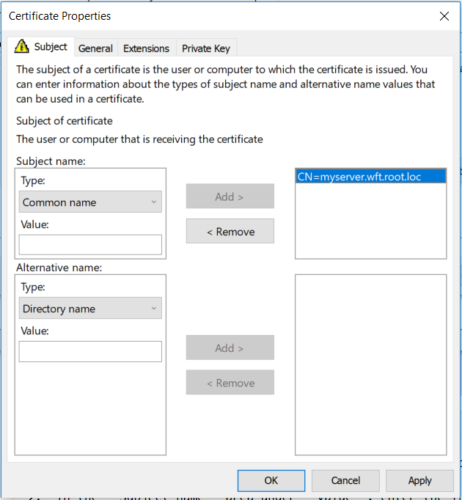

1. In the **Alternative name** area under **Type**, click **DNS**. In the **Alternative name** area under **Value**, enter the fully qualified domain name of the server, and then click **Add**. Repeat step 16 above for each additional SAN that you require.

**Note:** If you included a subject entry, you must include a SAN entry for it as well.

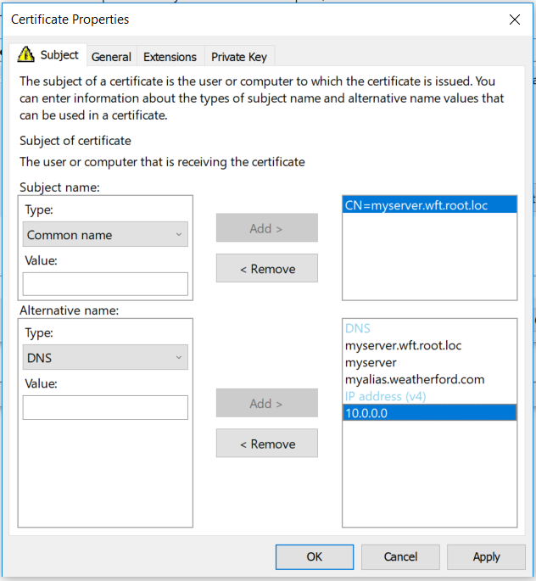

1. Verify all the subject and SAN entries and click the **General** tab.

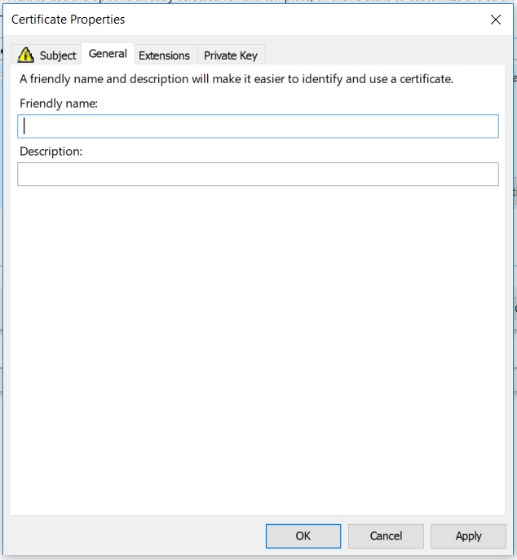

1. In the **Friendly name** area, enter appropriate name to identify certificate.

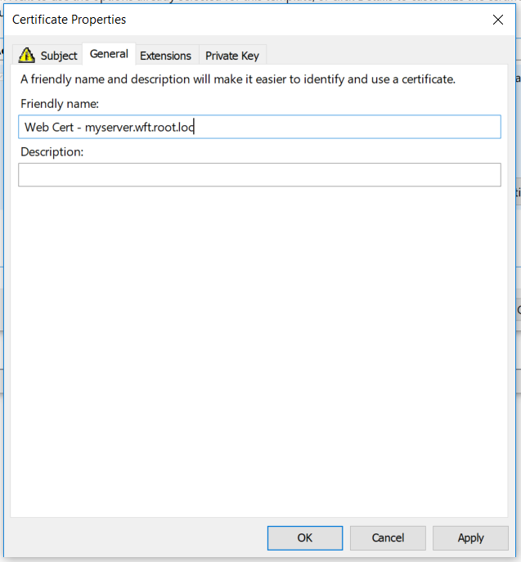

1. Click **Apply,** Click **OK** toclose **Certificate Properties** dialog box.

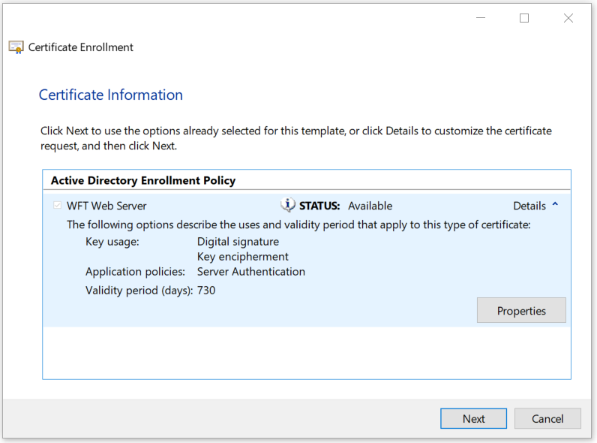

1. Click **Next**.

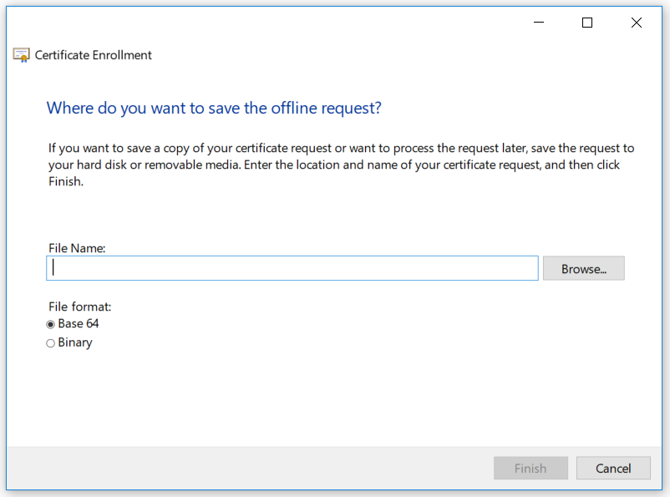

1. In **File Name** area, enter a file name for the new certificate request. Click **Browse** to view or change where to store request.

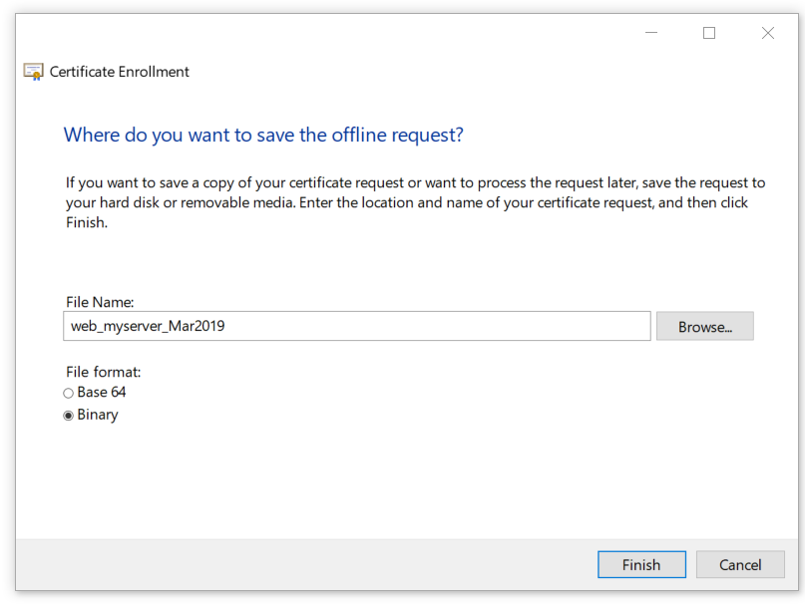

1. Click **Finish**.
2. Close MMC console.